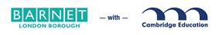
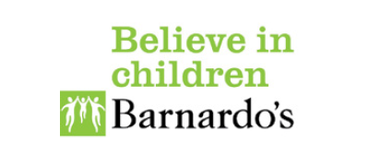

Cygnet parent/ carer autism training
A comprehensive training and support program for parents/ carers of children aged 5 -18, with a diagnosis of autism. This course is available free of charge to families living in Barnet.
Cygnet is a 6 week training course covering topics including:
- An overview of autism
- Communication
- Sensory needs
- Understanding behaviour
This course also gives parents/carers an opportunity to meet to meet each other and share their experiences.
At:  Holly Park School  Bellevue Road, Friern Barnet,  London N11 3HG | When:  Mondays 10-12  From 29th October 2018
The course is free but it is essential that parents/carers register
Contact Luci Rose from the Autism Advisory Team : Autism.Team@Barnet.gov.uk
Tel/ text : 07885208800

