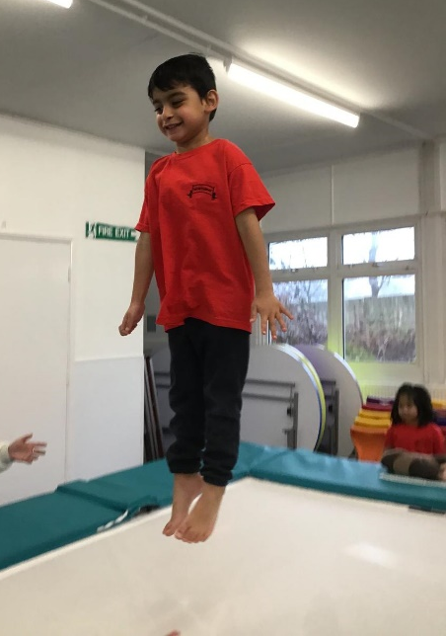
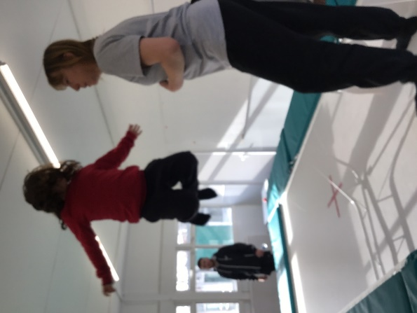
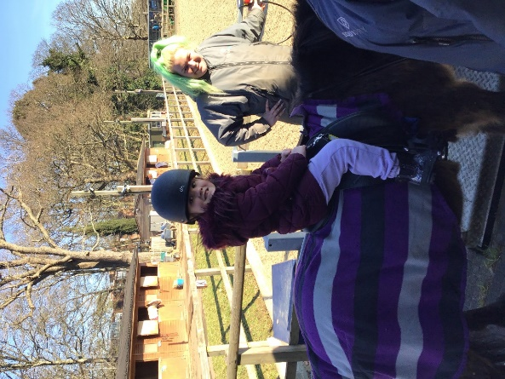

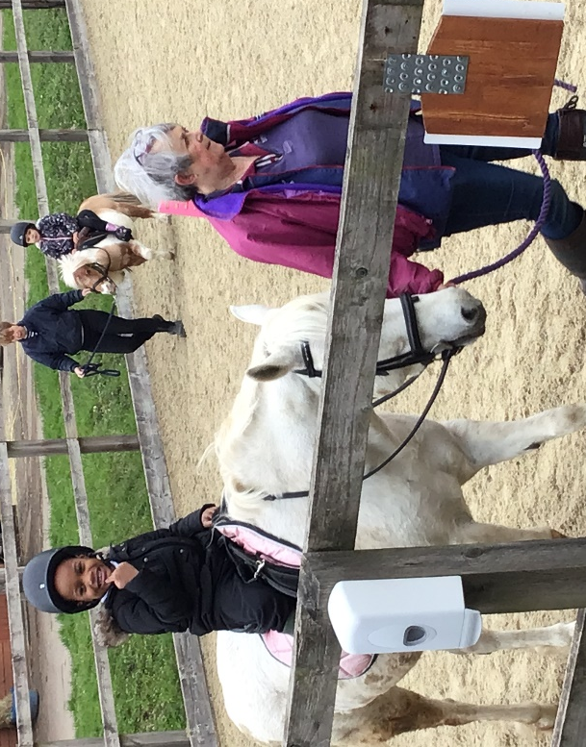

NORTHWAY SCHOOL
Sports Premium Statement
2022-2023
Details with regard to funding
Please complete the table below.

Total amount carried over from 2021/22 | £ 0
Total amount allocated for 2021/22 | £ £17068
How much (if any) do you intend to carry over from this total fund into 2022/23? | £0
Total amount allocated for 2022/23 | ££17,120
Total amount of funding for 2023/23. To be spent and reported on by 31st July 2023. | £ £17,120
Swimming Data
Please report on your Swimming Data below.

Meeting national curriculum requirements for swimming and water safety.

N.B. Complete this section to your best ability. For example you might have practised safe self-rescue techniques on dry land which you can then transfer to the pool when school swimming restarts.
Due to exceptional circumstances priority should be given to ensuring that pupils can perform safe self rescue even if they do not fully meet the first two requirements of the NC programme of study
What percentage of your current Year 6 cohort swim competently, confidently and proficiently over a distance of at least 25 metres?  N.B. Even though your pupils may swim in another year please report on their attainment on leaving primary school at the end of the summer term 2022.  Please see note above | NA
What percentage of your current Year 6 cohort use a range of strokes effectively [for example, front crawl, backstroke and breaststroke]?  Please see note above | NA
What percentage of your current Year 6 cohort perform safe self-rescue in different water-based situations? | NA
Schools can choose to use the Primary PE and sport premium to provide additional provision for swimming but this must be for activity over and above the national curriculum requirements. Have you used it in this way? | YES

Academic Year: 2022/23 | Total fund allocated: £17,120 | Date Updated: June 2023
Key indicator 1: The engagement of all pupils in regular physical activity – Chief Medical Officers guidelines recommend that primary school pupils undertake at least 30 minutes of physical activity a day in school |  |  |  | Percentage of total allocation:
 |  |  |  | 29%
Intent | Implementation |  | Impact
For all pupils on both school sites  to have regular PE sessions led by a PE / sports specialist  Adequate and age-appropriate resources and PE equipment available at both school sites;ensure adequate boccia resources on both sites | An additional member of staff at the Mill Hill site to take on responsibility for PE across the primary/secondary classes.  The two PE leaders (one at each site) liaise to develop programmes for sessions, organise resources and any extra curricula activities  Resources at both sites audited to identify any equipment required for next academic year  Low trampoline purchased for Infant site | £0  £5000approx | All pupils anticipate and respond positively to the range of activities offered by specialist PE leader.  Good practice in PE modelled for all staff  Youngest pupils become familiar with the PE hall, PE routines and co-operate with activities.  Pupils experience a wider array of activities and resources  Regular Rebound Therapy sessions provide exercise, enjoyment and motivation | Ongoing additional staff cost offset by increase in pupil numbers for next two years (and possibly longer)  Continue to have two PE  co-ordinators within school support staff  New resources purchased as a one off cost for what is needed following audit
Key indicator 2: The profile of PESSPA being raised across the school as a tool for whole school improvement |  |  |  | Percentage of total allocation:
 |  |  |  | % negligible
Intent | Implementation |  | Impact
Planning for all pupil learning is in place across all physical activities including eg use of cycles, use of trampoline etc | PE leaders begin to produce assessment criteria and guidelines for cycling sessions.  Liaise with staff to trial and report on these.  Time allocated in the timetable for all classes to use cycles  Consider appropriate stickers and certificates for cycling achievements | £0  £20 | Teaching is targeted to improve individual pupil skills in use of wheeled equipment and the trampoline  More pupils develop cycling skills and achieve appropriate certificates etc  Monitoring enables pupil progress to be shown.  Certificates and stickers provide pupils with a sense of achievement and tangible reinforcement.  Enables parents to see progress | Assessing and monitoring of PE skills has no financial cost.  PE curriculum programmes have no cost  PE leaders need non -contact time to complete actions and work with staff  Assessments for PE activities completed by PE leaders  Assessments shared with teachers; PE leaders and teachers work together to use these.

Key indicator 3: Increased confidence, knowledge and skills of all staff in teaching PE and sport |  |  |  | Percentage of total allocation:
 |  |  |  | 0%
Intent | Implementation |  | Impact
Training to be provided for staff new to school in aspects of physical education.  Updated training for more experienced classroom staff: including rebound therapy and leading swimming session training  Consider the training needs of new PE leader at Mill Hill site to gain appropriate specialist PE qualification | In house training for Sherborne  PE teacher to work alongside class teachers as they teach PE sessions and discuss these sessions together  Consideration of weekend Rebound therapy training for up to 12 staff members in next academic year  Identify provider to hold a Leading swimming session course in school pool (session to be run in next academic year) | £0  £0 | New staff will have increased awareness of a range of appropriate physical strategies and be able to support pupils more effectively.  Experiential activities such as Sherborne carried out more regularly  Rebound therapy activities can be carried out in sessions run by staff other than PE leaders which enables pupils to experience use of trampoline more often and improve skills  Qualified swimming leader always available for sessions and during holiday playscemes etc | No cost when school staff provide training on inset days  Staff work together and share good practice; staff will be more confident to lead PE sessions  Use designated inset days and twilight sessions to offer training
Key indicator 4: Broader experience of a range of sports and activities offered to all pupils |  |  |  | Percentage of total allocation:
 |  |  |  | 69%
Intent | Implementation |  | Impact
Experience of being near horses, willingness to engage in riding sessions and ability to follow very simple instructions from riding teachers regarding how to behave on a horse, how to encourage a horse to stop and go.  Continuation of participation by ALL pupils in weekly dance sessions led by a dance specialist from Lemon Jelly Performing Arts | For all Infant pupils to have three riding sessions in a specialised setting during each year in Early Years and KS1  For all Yr 7 pupils to engage weekly in riding for the disabled sessions  For all pupils across both sites to participate in weekly dance sessions | £1400  £1400  £9000 | Pupils will have experience of being on a horse and a greater confidence around horses  Pupils will understand that to go on a horse they need to co-operate with wearing boots and a riding helmet  Pupils gain enjoyment from joining in stimulating dance activities in a group setting | Riding sessions have ongoing costs  Continue to provide different riding sessions for all infant and secondary pupils  Ongoing costs for provision of twice weekly dance sessions

Key indicator 5: Increased participation in competitive sport |  |  |  | Percentage of total allocation:
 |  |  |  | 2%
Intent | Implementation |  | Impact
Increase the amount of intra-school activities at main site and introduce intra-school activities eg boccia at the infant site  Organise some shared activities eg boccia between both sites  Re-establish participation by pupils from Mill Hill site in off- site PE activities with other local special schools  Primary pupils compete in local Dance Festival | Ensure adequate resources eg for boccia at both sites  Continue to increase intra and inter sports activities including groups from the main site interacting with groups at the infant site on a regular basis  Identify other opportunities for Northway pupils to compete/work together with pupils from other special schools  Run a regular dance club to prepare a group of primary pupils to participate in the Barnet Dance Festival. | £300 | Pupils gain an understanding of teamwork; awareness of pupils other than those familiar to them  Pupils and their families gain a sense of achievement  Profile of SEND pupils raised | There is no ongoing cost to celebrating pupil achievements in PE within school and across the two school sites  There is no cost for participating in the local Dance Festival  No cost for activities between pupils from both sites  BPSS Buy in to access Panathlons etc (£300 pa)

