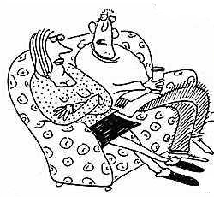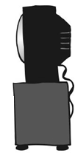
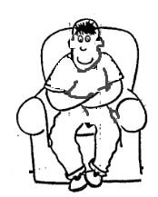

David is at home with his family.

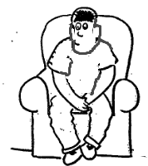

David begins to feel sexy and
wants to touch himself.
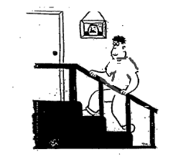

David goes up to his bedroom.
This is a private place

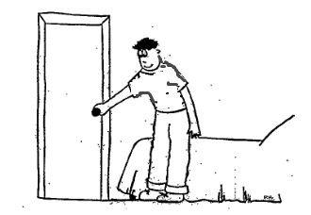
David closes the door.
He is on his own.
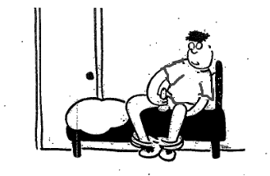
David wiggles his penis up and down.

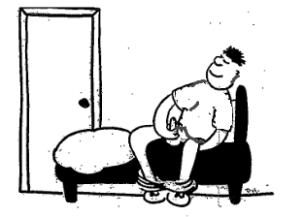

David enjoys this.
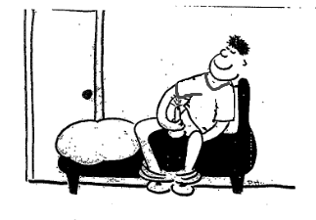
David ejaculates.
Sticky liquid comes out of David’s penis.

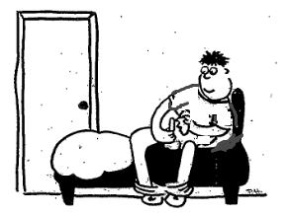
David wipes the sticky liquid away with tissues.
David puts the tissues in the bin.
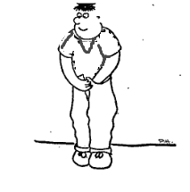
David puts his trousers back on
and does them up.

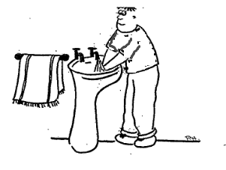
David washes his hands.

David goes back downstairs to his family.

