Home school visual timetable template
PECS symbols included

Before 9am | Wake up | 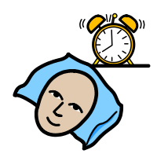 | Have breakfast  Get dressed  Brush your teeth  Make your bed  Tidy your room
9-10am | Exercise Time | 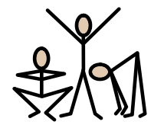 | If possible morning walk or indoor exercise.  i.e. jumping on trampette, bouncing on body ball, yoga, running/jumping games.  Youtube: Jack Hartman kids music channel, kids yoga, ‘just dance’.
10-11am | Focused activities | 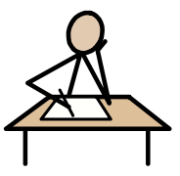 | Numeracy/literacy activities, fine motor activities, sensory activities.  (no electronics)
11-12pm | Creative activities | 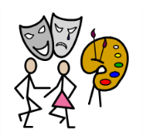 | Painting, drawing, crafts, singing, dancing, cooking.
12-1pm | Lunch / Relax | 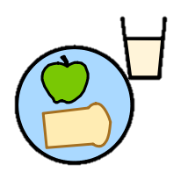 | Controlled electronics – ‘guided access’ used with specific apps/games, see list of apps used at school.
1-1.30pm | Exercise Time |  | If possible morning walk or indoor exercise.  i.e. jumping on trampette, bouncing on body ball, yoga, running/jumping games.  Youtube: Jack Hartman kids music channel, kids yoga, ‘just dance’.

1.30-2.30pm | Focused activities |  | Numeracy/literacy activities, fine motor activities, sensory activities.  (no electronics)
2.30-3pm | Quiet time | 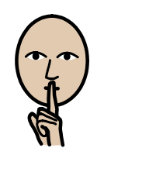 | Reading, massage, listening to calming music, watching tv programmes.
3-4pm | Fresh air |  | Outdoor play i.e. parks if possible, sand/water play in garden, trampoline.
4-5pm | Electronics Time | 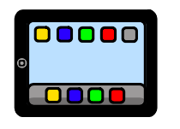 | Children to choose games/apps that they enjoy, adult supervision needed.
5-6pm | Dinner time | 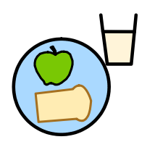 | Help prepare meal, set the table, sit down and enjoy dinner.
6pm after | Relaxation time | 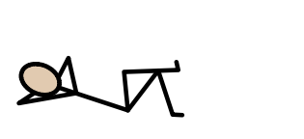 | Having a bath, reading a book, having a massage, listening to calming music.



